LINUX PRACTICE
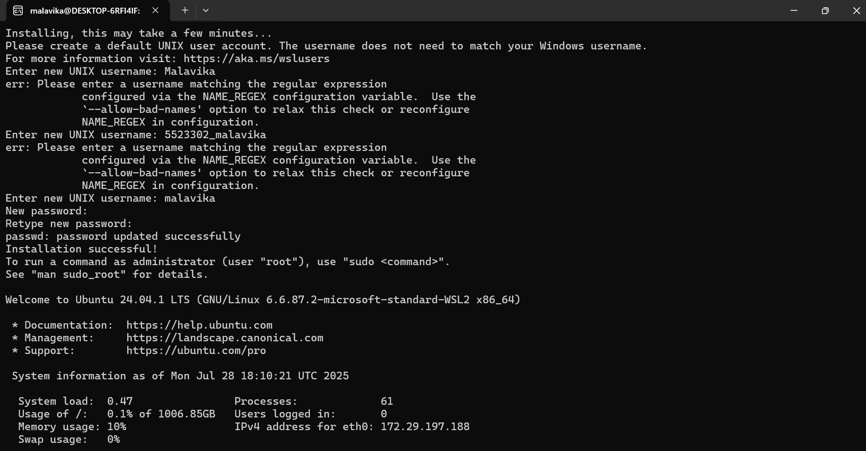
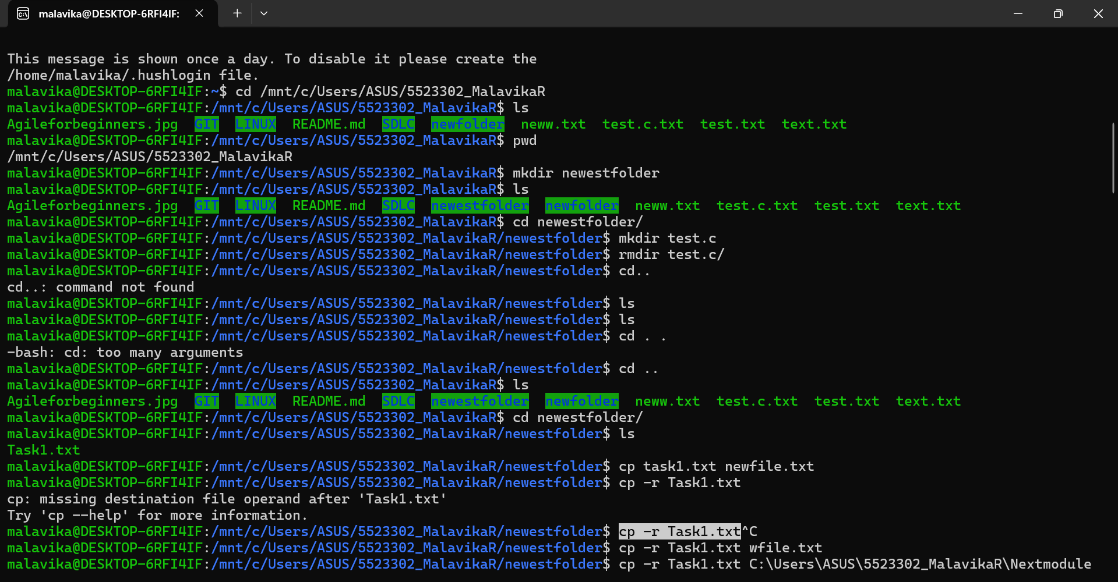
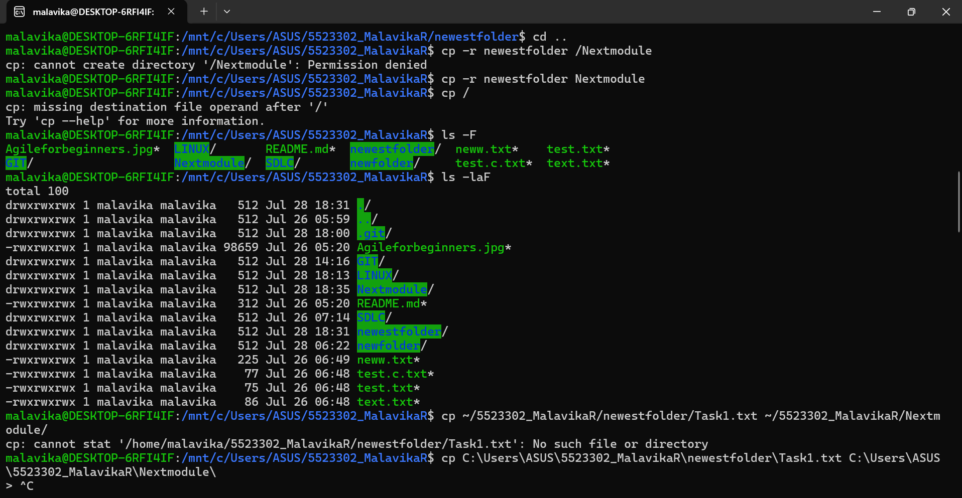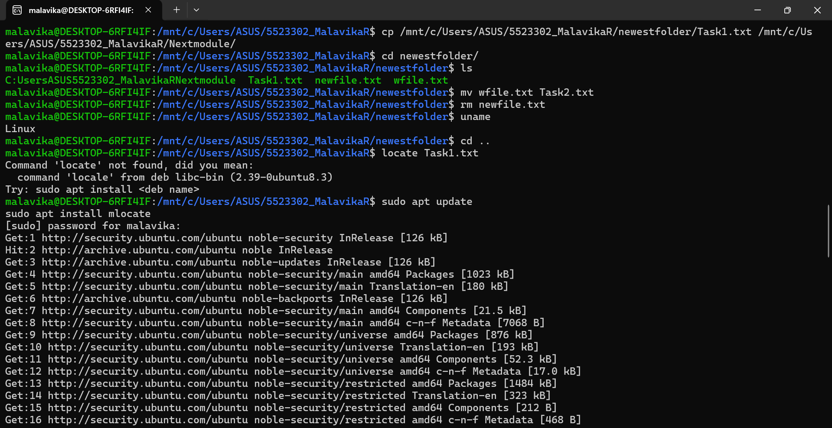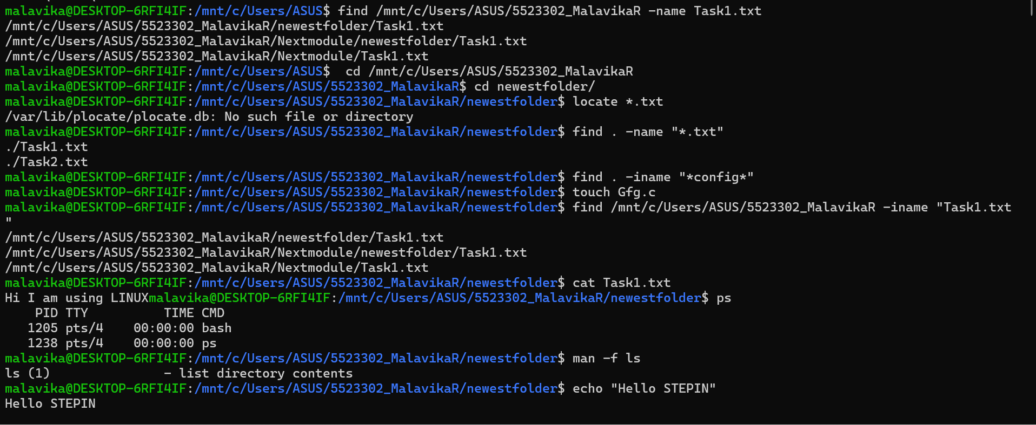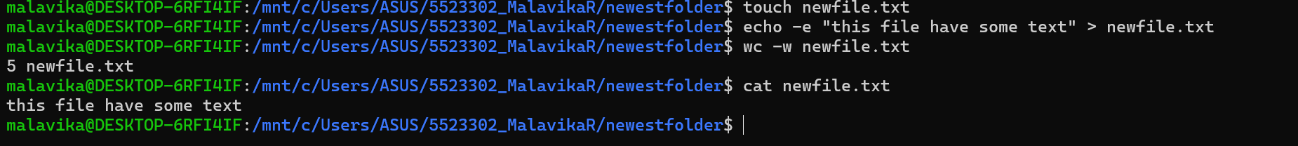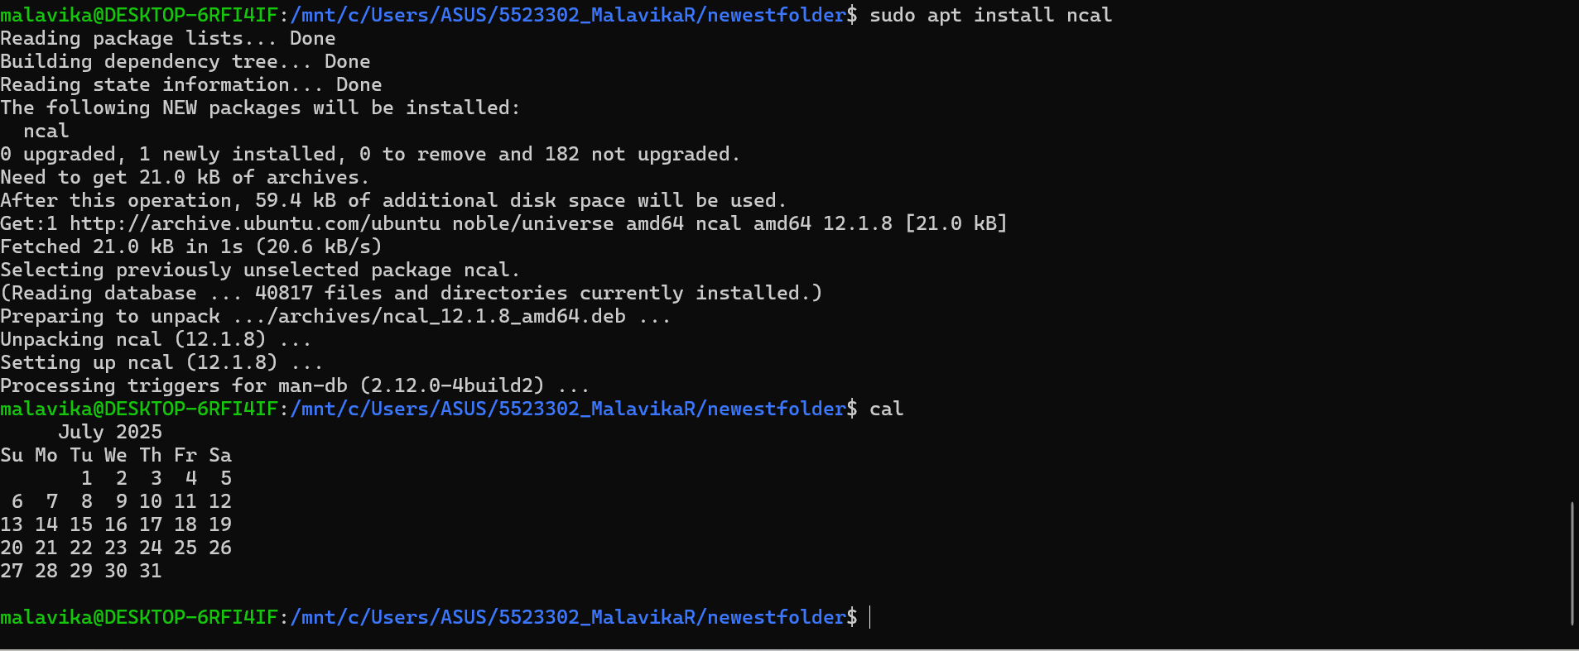
Text portion:
Installing, this may take a few minutes...
Please create a default UNIX user account. The username does not need to match your Windows username.
For more information visit: https://aka.ms/wslusers
Enter new UNIX username: Malavika
err: Please enter a username matching the regular expression
configured via the NAME_REGEX configuration variable. Use the
`--allow-bad-names' option to relax this check or reconfigure
NAME_REGEX in configuration.
Enter new UNIX username: 5523302_malavika
err: Please enter a username matching the regular expression
configured via the NAME_REGEX configuration variable. Use the
`--allow-bad-names' option to relax this check or reconfigure
NAME_REGEX in configuration.
Enter new UNIX username: malavika
New password:
Retype new password:
passwd: password updated successfully
Installation successful!
To run a command as administrator (user "root"), use "sudo <command>".
See "man sudo_root" for details.

Welcome to Ubuntu 24.04.1 LTS (GNU/Linux 6.6.87.2-microsoft-standard-WSL2 x86_64)

* Documentation: https://help.ubuntu.com
* Management: https://landscape.canonical.com
* Support: https://ubuntu.com/pro

System information as of Mon Jul 28 18:10:21 UTC 2025

System load: 0.47 Processes: 61
Usage of /: 0.1% of 1006.85GB Users logged in: 0
Memory usage: 10% IPv4 address for eth0: 172.29.197.188
Swap usage: 0%

This message is shown once a day. To disable it please create the
/home/malavika/.hushlogin file.
malavika@DESKTOP-6RFI4IF:~$ cd /mnt/c/Users/ASUS/5523302_MalavikaR
malavika@DESKTOP-6RFI4IF:/mnt/c/Users/ASUS/5523302_MalavikaR$ ls
Agileforbeginners.jpg GIT LINUX README.md SDLC newfolder neww.txt test.c.txt test.txt text.txt
malavika@DESKTOP-6RFI4IF:/mnt/c/Users/ASUS/5523302_MalavikaR$ pwd
/mnt/c/Users/ASUS/5523302_MalavikaR
malavika@DESKTOP-6RFI4IF:/mnt/c/Users/ASUS/5523302_MalavikaR$ mkdir newestfolder
malavika@DESKTOP-6RFI4IF:/mnt/c/Users/ASUS/5523302_MalavikaR$ ls
Agileforbeginners.jpg GIT LINUX README.md SDLC newestfolder newfolder neww.txt test.c.txt test.txt text.txt
malavika@DESKTOP-6RFI4IF:/mnt/c/Users/ASUS/5523302_MalavikaR$ cd newestfolder/
malavika@DESKTOP-6RFI4IF:/mnt/c/Users/ASUS/5523302_MalavikaR/newestfolder$ mkdir test.c
malavika@DESKTOP-6RFI4IF:/mnt/c/Users/ASUS/5523302_MalavikaR/newestfolder$ rmdir test.c/
malavika@DESKTOP-6RFI4IF:/mnt/c/Users/ASUS/5523302_MalavikaR/newestfolder$ cd..
cd..: command not found
malavika@DESKTOP-6RFI4IF:/mnt/c/Users/ASUS/5523302_MalavikaR/newestfolder$ ls
malavika@DESKTOP-6RFI4IF:/mnt/c/Users/ASUS/5523302_MalavikaR/newestfolder$ ls
malavika@DESKTOP-6RFI4IF:/mnt/c/Users/ASUS/5523302_MalavikaR/newestfolder$ cd . .
-bash: cd: too many arguments
malavika@DESKTOP-6RFI4IF:/mnt/c/Users/ASUS/5523302_MalavikaR/newestfolder$ cd ..
malavika@DESKTOP-6RFI4IF:/mnt/c/Users/ASUS/5523302_MalavikaR$ ls
Agileforbeginners.jpg GIT LINUX README.md SDLC newestfolder newfolder neww.txt test.c.txt test.txt text.txt
malavika@DESKTOP-6RFI4IF:/mnt/c/Users/ASUS/5523302_MalavikaR$ cd newestfolder/
malavika@DESKTOP-6RFI4IF:/mnt/c/Users/ASUS/5523302_MalavikaR/newestfolder$ ls
Task1.txt
malavika@DESKTOP-6RFI4IF:/mnt/c/Users/ASUS/5523302_MalavikaR/newestfolder$ cp task1.txt newfile.txt
malavika@DESKTOP-6RFI4IF:/mnt/c/Users/ASUS/5523302_MalavikaR/newestfolder$ cp -r Task1.txt
cp: missing destination file operand after 'Task1.txt'
Try 'cp --help' for more information.
malavika@DESKTOP-6RFI4IF:/mnt/c/Users/ASUS/5523302_MalavikaR/newestfolder$ cp -r Task1.txt^C
malavika@DESKTOP-6RFI4IF:/mnt/c/Users/ASUS/5523302_MalavikaR/newestfolder$ cp -r Task1.txt wfile.txt
malavika@DESKTOP-6RFI4IF:/mnt/c/Users/ASUS/5523302_MalavikaR/newestfolder$ cp -r Task1.txt C:\Users\ASUS\5523302_MalavikaR\Nextmodule
malavika@DESKTOP-6RFI4IF:/mnt/c/Users/ASUS/5523302_MalavikaR/newestfolder$ cd ..
malavika@DESKTOP-6RFI4IF:/mnt/c/Users/ASUS/5523302_MalavikaR$ cp -r newestfolder /Nextmodule
cp: cannot create directory '/Nextmodule': Permission denied
malavika@DESKTOP-6RFI4IF:/mnt/c/Users/ASUS/5523302_MalavikaR$ cp -r newestfolder Nextmodule
malavika@DESKTOP-6RFI4IF:/mnt/c/Users/ASUS/5523302_MalavikaR$ cp /
cp: missing destination file operand after '/'
Try 'cp --help' for more information.
malavika@DESKTOP-6RFI4IF:/mnt/c/Users/ASUS/5523302_MalavikaR$ ls -F
Agileforbeginners.jpg* LINUX/ README.md* newestfolder/ neww.txt* test.txt*
GIT/ Nextmodule/ SDLC/ newfolder/ test.c.txt* text.txt*
malavika@DESKTOP-6RFI4IF:/mnt/c/Users/ASUS/5523302_MalavikaR$ ls -laF
total 100
drwxrwxrwx 1 malavika malavika 512 Jul 28 18:31 ./
drwxrwxrwx 1 malavika malavika 512 Jul 26 05:59 ../
drwxrwxrwx 1 malavika malavika 512 Jul 28 18:00 .git/
-rwxrwxrwx 1 malavika malavika 98659 Jul 26 05:20 Agileforbeginners.jpg*
drwxrwxrwx 1 malavika malavika 512 Jul 28 14:16 GIT/
drwxrwxrwx 1 malavika malavika 512 Jul 28 18:13 LINUX/
drwxrwxrwx 1 malavika malavika 512 Jul 28 18:35 Nextmodule/
-rwxrwxrwx 1 malavika malavika 312 Jul 26 05:20 README.md*
drwxrwxrwx 1 malavika malavika 512 Jul 26 07:14 SDLC/
drwxrwxrwx 1 malavika malavika 512 Jul 28 18:31 newestfolder/
drwxrwxrwx 1 malavika malavika 512 Jul 28 06:22 newfolder/
-rwxrwxrwx 1 malavika malavika 225 Jul 26 06:49 neww.txt*
-rwxrwxrwx 1 malavika malavika 77 Jul 26 06:48 test.c.txt*
-rwxrwxrwx 1 malavika malavika 75 Jul 26 06:48 test.txt*
-rwxrwxrwx 1 malavika malavika 86 Jul 26 06:48 text.txt*
malavika@DESKTOP-6RFI4IF:/mnt/c/Users/ASUS/5523302_MalavikaR$ cp ~/5523302_MalavikaR/newestfolder/Task1.txt ~/5523302_MalavikaR/Nextmodule/
cp: cannot stat '/home/malavika/5523302_MalavikaR/newestfolder/Task1.txt': No such file or directory
malavika@DESKTOP-6RFI4IF:/mnt/c/Users/ASUS/5523302_MalavikaR$ cp C:\Users\ASUS\5523302_MalavikaR\newestfolder\Task1.txt C:\Users\ASUS\5523302_MalavikaR\Nextmodule\
> ^C
malavika@DESKTOP-6RFI4IF:/mnt/c/Users/ASUS/5523302_MalavikaR$ cp /mnt/c/Users/ASUS/5523302_MalavikaR/newestfolder/Task1.txt /mnt/c/Users/ASUS/5523302_MalavikaR/Nextmodule/
malavika@DESKTOP-6RFI4IF:/mnt/c/Users/ASUS/5523302_MalavikaR$ cd newestfolder/
malavika@DESKTOP-6RFI4IF:/mnt/c/Users/ASUS/5523302_MalavikaR/newestfolder$ ls
C:UsersASUS5523302_MalavikaRNextmodule Task1.txt newfile.txt wfile.txt
malavika@DESKTOP-6RFI4IF:/mnt/c/Users/ASUS/5523302_MalavikaR/newestfolder$ mv wfile.txt Task2.txt
malavika@DESKTOP-6RFI4IF:/mnt/c/Users/ASUS/5523302_MalavikaR/newestfolder$ rm newfile.txt
malavika@DESKTOP-6RFI4IF:/mnt/c/Users/ASUS/5523302_MalavikaR/newestfolder$ uname
Linux
malavika@DESKTOP-6RFI4IF:/mnt/c/Users/ASUS/5523302_MalavikaR/newestfolder$ cd ..
malavika@DESKTOP-6RFI4IF:/mnt/c/Users/ASUS/5523302_MalavikaR$ locate Task1.txt
Command 'locate' not found, did you mean:
command 'locale' from deb libc-bin (2.39-0ubuntu8.3)
Try: sudo apt install <deb name>
malavika@DESKTOP-6RFI4IF:/mnt/c/Users/ASUS/5523302_MalavikaR$ sudo apt update
sudo apt install mlocate
[sudo] password for malavika:
Get:1 http://security.ubuntu.com/ubuntu noble-security InRelease [126 kB]
Hit:2 http://archive.ubuntu.com/ubuntu noble InRelease
Get:3 http://archive.ubuntu.com/ubuntu noble-updates InRelease [126 kB]
Get:4 http://security.ubuntu.com/ubuntu noble-security/main amd64 Packages [1023 kB]
Get:5 http://security.ubuntu.com/ubuntu noble-security/main Translation-en [180 kB]
Get:6 http://archive.ubuntu.com/ubuntu noble-backports InRelease [126 kB]
Get:7 http://security.ubuntu.com/ubuntu noble-security/main amd64 Components [21.5 kB]
Get:8 http://security.ubuntu.com/ubuntu noble-security/main amd64 c-n-f Metadata [7068 B]
Get:9 http://security.ubuntu.com/ubuntu noble-security/universe amd64 Packages [876 kB]
Get:10 http://security.ubuntu.com/ubuntu noble-security/universe Translation-en [193 kB]
Get:11 http://security.ubuntu.com/ubuntu noble-security/universe amd64 Components [52.3 kB]
Get:12 http://security.ubuntu.com/ubuntu noble-security/universe amd64 c-n-f Metadata [17.0 kB]
Get:13 http://security.ubuntu.com/ubuntu noble-security/restricted amd64 Packages [1484 kB]
Get:14 http://security.ubuntu.com/ubuntu noble-security/restricted Translation-en [323 kB]
Get:15 http://security.ubuntu.com/ubuntu noble-security/restricted amd64 Components [212 B]
Get:16 http://security.ubuntu.com/ubuntu noble-security/restricted amd64 c-n-f Metadata [468 B]
Get:17 http://security.ubuntu.com/ubuntu noble-security/multiverse amd64 Packages [18.5 kB]
Get:18 http://security.ubuntu.com/ubuntu noble-security/multiverse Translation-en [4288 B]
Get:19 http://security.ubuntu.com/ubuntu noble-security/multiverse amd64 Components [212 B]
Get:20 http://archive.ubuntu.com/ubuntu noble/universe amd64 Packages [15.0 MB]
Get:21 http://security.ubuntu.com/ubuntu noble-security/multiverse amd64 c-n-f Metadata [380 B]
Get:22 http://archive.ubuntu.com/ubuntu noble/universe Translation-en [5982 kB]
Get:23 http://archive.ubuntu.com/ubuntu noble/universe amd64 Components [3871 kB]
Get:24 http://archive.ubuntu.com/ubuntu noble/universe amd64 c-n-f Metadata [301 kB]
Get:25 http://archive.ubuntu.com/ubuntu noble/multiverse amd64 Packages [269 kB]
Get:26 http://archive.ubuntu.com/ubuntu noble/multiverse Translation-en [118 kB]
Get:27 http://archive.ubuntu.com/ubuntu noble/multiverse amd64 Components [35.0 kB]
Get:28 http://archive.ubuntu.com/ubuntu noble/multiverse amd64 c-n-f Metadata [8328 B]
Get:29 http://archive.ubuntu.com/ubuntu noble-updates/main amd64 Packages [1282 kB]
Get:30 http://archive.ubuntu.com/ubuntu noble-updates/main Translation-en [260 kB]
Get:31 http://archive.ubuntu.com/ubuntu noble-updates/main amd64 Components [163 kB]
Get:32 http://archive.ubuntu.com/ubuntu noble-updates/main amd64 c-n-f Metadata [13.5 kB]
Get:33 http://archive.ubuntu.com/ubuntu noble-updates/universe amd64 Packages [1113 kB]
Get:34 http://archive.ubuntu.com/ubuntu noble-updates/universe Translation-en [284 kB]
Get:35 http://archive.ubuntu.com/ubuntu noble-updates/universe amd64 Components [377 kB]
Get:36 http://archive.ubuntu.com/ubuntu noble-updates/universe amd64 c-n-f Metadata [26.0 kB]
Get:37 http://archive.ubuntu.com/ubuntu noble-updates/restricted amd64 Packages [1572 kB]
Get:38 http://archive.ubuntu.com/ubuntu noble-updates/restricted Translation-en [341 kB]
Get:39 http://archive.ubuntu.com/ubuntu noble-updates/restricted amd64 Components [212 B]
Get:40 http://archive.ubuntu.com/ubuntu noble-updates/restricted amd64 c-n-f Metadata [492 B]
Get:41 http://archive.ubuntu.com/ubuntu noble-updates/multiverse amd64 Packages [33.2 kB]
Get:42 http://archive.ubuntu.com/ubuntu noble-updates/multiverse Translation-en [6772 B]
Get:43 http://archive.ubuntu.com/ubuntu noble-updates/multiverse amd64 Components [940 B]
Get:44 http://archive.ubuntu.com/ubuntu noble-updates/multiverse amd64 c-n-f Metadata [592 B]
Get:45 http://archive.ubuntu.com/ubuntu noble-backports/main amd64 Packages [39.9 kB]
Get:46 http://archive.ubuntu.com/ubuntu noble-backports/main Translation-en [9152 B]
Get:47 http://archive.ubuntu.com/ubuntu noble-backports/main amd64 Components [7056 B]
Get:48 http://archive.ubuntu.com/ubuntu noble-backports/main amd64 c-n-f Metadata [272 B]
Get:49 http://archive.ubuntu.com/ubuntu noble-backports/universe amd64 Packages [28.0 kB]
Get:50 http://archive.ubuntu.com/ubuntu noble-backports/universe Translation-en [17.1 kB]
Get:51 http://archive.ubuntu.com/ubuntu noble-backports/universe amd64 Components [28.3 kB]
Get:52 http://archive.ubuntu.com/ubuntu noble-backports/universe amd64 c-n-f Metadata [1304 B]
Get:53 http://archive.ubuntu.com/ubuntu noble-backports/restricted amd64 Components [216 B]
Get:54 http://archive.ubuntu.com/ubuntu noble-backports/restricted amd64 c-n-f Metadata [116 B]
Get:55 http://archive.ubuntu.com/ubuntu noble-backports/multiverse amd64 Components [212 B]
Get:56 http://archive.ubuntu.com/ubuntu noble-backports/multiverse amd64 c-n-f Metadata [116 B]
Fetched 35.8 MB in 8s (4509 kB/s)
Reading package lists... Done
Building dependency tree... Done
Reading state information... Done
182 packages can be upgraded. Run 'apt list --upgradable' to see them.
Reading package lists... Done
Building dependency tree... Done
Reading state information... Done
E: Unable to locate package mlocate
malavika@DESKTOP-6RFI4IF:/mnt/c/Users/ASUS/5523302_MalavikaR$ locate Task1.txt
Command 'locate' not found, but can be installed with:
sudo apt install plocate
malavika@DESKTOP-6RFI4IF:/mnt/c/Users/ASUS/5523302_MalavikaR$ sudo apt update
sudo apt install plocate
Hit:1 http://security.ubuntu.com/ubuntu noble-security InRelease
Hit:2 http://archive.ubuntu.com/ubuntu noble InRelease
Hit:3 http://archive.ubuntu.com/ubuntu noble-updates InRelease
Hit:4 http://archive.ubuntu.com/ubuntu noble-backports InRelease
Reading package lists... Done
Building dependency tree... Done
Reading state information... Done
182 packages can be upgraded. Run 'apt list --upgradable' to see them.
Reading package lists... Done
Building dependency tree... Done
Reading state information... Done
The following additional packages will be installed:
liburing2
The following NEW packages will be installed:
liburing2 plocate
0 upgraded, 2 newly installed, 0 to remove and 182 not upgraded.
Need to get 160 kB of archives.
After this operation, 623 kB of additional disk space will be used.
Do you want to continue? [Y/n] Y
Get:1 http://archive.ubuntu.com/ubuntu noble/main amd64 liburing2 amd64 2.5-1build1 [21.1 kB]
Get:2 http://archive.ubuntu.com/ubuntu noble/universe amd64 plocate amd64 1.1.19-2ubuntu2 [139 kB]
Fetched 160 kB in 1s (171 kB/s)
Selecting previously unselected package liburing2:amd64.
(Reading database ... 40794 files and directories currently installed.)
Preparing to unpack .../liburing2_2.5-1build1_amd64.deb ...
Unpacking liburing2:amd64 (2.5-1build1) ...
Selecting previously unselected package plocate.
Preparing to unpack .../plocate_1.1.19-2ubuntu2_amd64.deb ...
Unpacking plocate (1.1.19-2ubuntu2) ...
Setting up liburing2:amd64 (2.5-1build1) ...
Setting up plocate (1.1.19-2ubuntu2) ...
update-alternatives: using /usr/bin/plocate to provide /usr/bin/locate (locate) in auto mode
info: Selecting GID from range 100 to 999 ...
info: Adding group `plocate' (GID 108) ...
Initializing plocate database; this may take some time... done
Created symlink /etc/systemd/system/timers.target.wants/plocate-updatedb.timer → /usr/lib/systemd/system/plocate-updatedb.timer.
Processing triggers for man-db (2.12.0-4build2) ...
Processing triggers for libc-bin (2.39-0ubuntu8.3) ...
/sbin/ldconfig.real: /usr/lib/wsl/lib/libcuda.so.1 is not a symbolic link

W: Operation was interrupted before it could finish
malavika@DESKTOP-6RFI4IF:/mnt/c/Users/ASUS/5523302_MalavikaR$
Windows PowerShell
Copyright (C) Microsoft Corporation. All rights reserved.

Install the latest PowerShell for new features and improvements! https://aka.ms/PSWindows

PS C:\Users\ASUS> wsl
malavika@DESKTOP-6RFI4IF:/mnt/c/Users/ASUS$ find /mnt/c/Users/ASUS/5523302_MalavikaR -name Task1.txt
/mnt/c/Users/ASUS/5523302_MalavikaR/newestfolder/Task1.txt
/mnt/c/Users/ASUS/5523302_MalavikaR/Nextmodule/newestfolder/Task1.txt
/mnt/c/Users/ASUS/5523302_MalavikaR/Nextmodule/Task1.txt
malavika@DESKTOP-6RFI4IF:/mnt/c/Users/ASUS$ cd /mnt/c/Users/ASUS/5523302_MalavikaR
malavika@DESKTOP-6RFI4IF:/mnt/c/Users/ASUS/5523302_MalavikaR$ cd newestfolder/
malavika@DESKTOP-6RFI4IF:/mnt/c/Users/ASUS/5523302_MalavikaR/newestfolder$ locate *.txt
/var/lib/plocate/plocate.db: No such file or directory
malavika@DESKTOP-6RFI4IF:/mnt/c/Users/ASUS/5523302_MalavikaR/newestfolder$ find . -name "*.txt"
./Task1.txt
./Task2.txt
malavika@DESKTOP-6RFI4IF:/mnt/c/Users/ASUS/5523302_MalavikaR/newestfolder$ find . -iname "*config*"
malavika@DESKTOP-6RFI4IF:/mnt/c/Users/ASUS/5523302_MalavikaR/newestfolder$ touch Gfg.c
malavika@DESKTOP-6RFI4IF:/mnt/c/Users/ASUS/5523302_MalavikaR/newestfolder$ find /mnt/c/Users/ASUS/5523302_MalavikaR -iname "Task1.txt"
/mnt/c/Users/ASUS/5523302_MalavikaR/newestfolder/Task1.txt
/mnt/c/Users/ASUS/5523302_MalavikaR/Nextmodule/newestfolder/Task1.txt
/mnt/c/Users/ASUS/5523302_MalavikaR/Nextmodule/Task1.txt
malavika@DESKTOP-6RFI4IF:/mnt/c/Users/ASUS/5523302_MalavikaR/newestfolder$ cat Task1.txt
Hi I am using LINUXmalavika@DESKTOP-6RFI4IF:/mnt/c/Users/ASUS/5523302_MalavikaR/newestfolder$ ps
PID TTY TIME CMD
1205 pts/4 00:00:00 bash
1238 pts/4 00:00:00 ps
malavika@DESKTOP-6RFI4IF:/mnt/c/Users/ASUS/5523302_MalavikaR/newestfolder$ man -f ls
ls (1) - list directory contents
malavika@DESKTOP-6RFI4IF:/mnt/c/Users/ASUS/5523302_MalavikaR/newestfolder$ echo "Hello STEPIN"
Hello STEPIN
malavika@DESKTOP-6RFI4IF:/mnt/c/Users/ASUS/5523302_MalavikaR/newestfolder$ cal
Command 'cal' not found, but can be installed with:
sudo apt install ncal
malavika@DESKTOP-6RFI4IF:/mnt/c/Users/ASUS/5523302_MalavikaR/newestfolder$ sudo apt install ncal
[sudo] password for malavika:
Waiting for cache lock: Could not get lock /var/lib/dpkg/lock-frontend. It is held by process 1107 (apt)
Waiting for cache lock: Could not get lock /var/lib/dpkg/lock-frontend. It is held by process 1107 (apt)
Waiting for cache lock: Could not get lock /var/lib/dpkg/lock-frontend. It is held by process 1107 (apt)
Waiting for cache lock: Could not get lock /var/lib/dpkg/lock-frontend. It is held by process 1107 (apt)
Waiting for cache lock: Could not get lock /var/lib/dpkg/lock-frontend. It is held by process 1107 (apt)
Waiting for cache lock: Could not get lock /var/lib/dpkg/lock-frontend. It is held by process 1107 (apt)
Waiting for cache lock: Could not get lock /var/lib/dpkg/lock-frontend. It is held by process 1107 (apt)
Waiting for cache lock: Could not get lock /var/lib/dpkg/lock-frontend. It is held by process 1107 (apt)
Waiting for cache lock: Could not get lock /var/lib/dpkg/lock-frontend. It is held by process 1107 (apt)
Waiting for cache lock: Could not get lock /var/lib/dpkg/lock-frontend. It is held by process 1107 (apt)
Waiting for cache lock: Could not get lock /var/lib/dpkg/lock-frontend. It is held by process 1107 (apt)
Waiting for cache lock: Could not get lock /var/lib/dpkg/lock-frontend. It is held by process 1107 (apt)
Waiting for cache lock: Could not get lock /var/lib/dpkg/lock-frontend. It is held by process 1107 (apt)
Waiting for cache lock: Could not get lock /var/lib/dpkg/lock-frontend. It is held by process 1107 (apt)
Waiting for cache lock: Could not get lock /var/lib/dpkg/lock-frontend. It is held by process 1107 (apt)
Waiting for cache lock: Could not get lock /var/lib/dpkg/lock-frontend. It is held by process 1107 (apt)
Waiting for cache lock: Could not get lock /var/lib/dpkg/lock-frontend. It is held by process 1107 (apt)
Waiting for cache lock: Could not get lock /var/lib/dpkg/lock-frontend. It is held by process 1107 (apt)
Waiting for cache lock: Could not get lock /var/lib/dpkg/lock-frontend. It is held by process 1107 (apt)
Waiting for cache lock: Could not get lock /var/lib/dpkg/lock-frontend. It is held by process 1107 (apt)
Waiting for cache lock: Could not get lock /var/lib/dpkg/lock-frontend. It is held by process 1107 (apt)
Waiting for cache lock: Could not get lock /var/lib/dpkg/lock-frontend. It is held by process 1107 (apt)
Waiting for cache lock: Could not get lock /var/lib/dpkg/lock-frontend. It is held by process 1107 (apt)
Waiting for cache lock: Could not get lock /var/lib/dpkg/lock-frontend. It is held by process 1107 (apt)
Waiting for cache lock: Could not get lock /var/lib/dpkg/lock-frontend. It is held by process 1107 (apt)
Waiting for cache lock: Could not get lock /var/lib/dpkg/lock-frontend. It is held by process 1107 (apt)
Waiting for cache lock: Could not get lock /var/lib/dpkg/lock-frontend. It is held by process 1107 (apt)
Waiting for cache lock: Could not get lock /var/lib/dpkg/lock-frontend. It is held by process 1107 (apt)
Waiting for cache lock: Could not get lock /var/lib/dpkg/lock-frontend. It is held by process 1107 (apt)
Waiting for cache lock: Could not get lock /var/lib/dpkg/lock-frontend. It is held by process 1107 (apt)
Waiting for cache lock: Could not get lock /var/lib/dpkg/lock-frontend. It is held by process 1107 (apt)
Waiting for cache lock: Could not get lock /var/lib/dpkg/lock-frontend. It is held by process 1107 (apt)
Waiting for cache lock: Could not get lock /var/lib/dpkg/lock-frontend. It is held by process 1107 (apt)
Waiting for cache lock: Could not get lock /var/lib/dpkg/lock-frontend. It is held by process 1107 (apt)
Waiting for cache lock: Could not get lock /var/lib/dpkg/lock-frontend. It is held by process 1107 (apt)
Waiting for cache lock: Could not get lock /var/lib/dpkg/lock-frontend. It is held by process 1107 (apt)
Waiting for cache lock: Could not get lock /var/lib/dpkg/lock-frontend. It is held by process 1107 (apt)
Waiting for cache lock: Could not get lock /var/lib/dpkg/lock-frontend. It is held by process 1107 (apt)
Waiting for cache lock: Could not get lock /var/lib/dpkg/lock-frontend. It is held by process 1107 (apt)
Waiting for cache lock: Could not get lock /var/lib/dpkg/lock-frontend. It is held by process 1107 (apt)
Waiting for cache lock: Could not get lock /var/lib/dpkg/lock-frontend. It is held by process 1107 (apt)
Waiting for cache lock: Could not get lock /var/lib/dpkg/lock-frontend. It is held by process 1107 (apt)
Waiting for cache lock: Could not get lock /var/lib/dpkg/lock-frontend. It is held by process 1107 (apt)
Waiting for cache lock: Could not get lock /var/lib/dpkg/lock-frontend. It is held by process 1107 (apt)
Waiting for cache lock: Could not get lock /var/lib/dpkg/lock-frontend. It is held by process 1107 (apt)
Waiting for cache lock: Could not get lock /var/lib/dpkg/lock-frontend. It is held by process 1107 (apt)
Waiting for cache lock: Could not get lock /var/lib/dpkg/lock-frontend. It is held by process 1107 (apt)
Waiting for cache lock: Could not get lock /var/lib/dpkg/lock-frontend. It is held by process 1107 (apt)
Waiting for cache lock: Could not get lock /var/lib/dpkg/lock-frontend. It is held by process 1107 (apt)
Waiting for cache lock: Could not get lock /var/lib/dpkg/lock-frontend. It is held by process 1107 (apt)
Waiting for cache lock: Could not get lock /var/lib/dpkg/lock-frontend. It is held by process 1107 (apt)
Waiting for cache lock: Could not get lock /var/lib/dpkg/lock-frontend. It is held by process 1107 (apt)
Waiting for cache lock: Could not get lock /var/lib/dpkg/lock-frontend. It is held by process 1107 (apt)
Waiting for cache lock: Could not get lock /var/lib/dpkg/lock-frontend. It is held by process 1107 (apt)
Waiting for cache lock: Could not get lock /var/lib/dpkg/lock-frontend. It is held by process 1107 (apt)
Waiting for cache lock: Could not get lock /var/lib/dpkg/lock-frontend. It is held by process 1107 (apt)
Waiting for cache lock: Could not get lock /var/lib/dpkg/lock-frontend. It is held by process 1107 (apt)
Waiting for cache lock: Could not get lock /var/lib/dpkg/lock-frontend. It is held by process 1107 (apt)
Waiting for cache lock: Could not get lock /var/lib/dpkg/lock-frontend. It is held by process 1107 (apt)
Waiting for cache lock: Could not get lock /var/lib/dpkg/lock-frontend. It is held by process 1107 (apt)
Waiting for cache lock: Could not get lock /var/lib/dpkg/lock-frontend. It is held by process 1107 (apt)
Waiting for cache lock: Could not get lock /var/lib/dpkg/lock-frontend. It is held by process 1107 (apt)
Waiting for cache lock: Could not get lock /var/lib/dpkg/lock-frontend. It is held by process 1107 (apt)
Waiting for cache lock: Could not get lock /var/lib/dpkg/lock-frontend. It is held by process 1107 (apt)
Waiting for cache lock: Could not get lock /var/lib/dpkg/lock-frontend. It is held by process 1107 (apt)
Waiting for cache lock: Could not get lock /var/lib/dpkg/lock-frontend. It is held by process 1107 (apt)
Waiting for cache lock: Could not get lock /var/lib/dpkg/lock-frontend. It is held by process 1107 (apt)
Waiting for cache lock: Could not get lock /var/lib/dpkg/lock-frontend. It is held by process 1107 (apt)
Waiting for cache lock: Could not get lock /var/lib/dpkg/lock-frontend. It is held by process 1107 (apt)
Waiting for cache lock: Could not get lock /var/lib/dpkg/lock-frontend. It is held by process 1107 (apt)
Waiting for cache lock: Could not get lock /var/lib/dpkg/lock-frontend. It is held by process 1107 (apt)
Waiting for cache lock: Could not get lock /var/lib/dpkg/lock-frontend. It is held by process 1107 (apt)
Waiting for cache lock: Could not get lock /var/lib/dpkg/lock-frontend. It is held by process 1107 (apt)
Waiting for cache lock: Could not get lock /var/lib/dpkg/lock-frontend. It is held by process 1107 (apt)
Waiting for cache lock: Could not get lock /var/lib/dpkg/lock-frontend. It is held by process 1107 (apt)
Waiting for cache lock: Could not get lock /var/lib/dpkg/lock-frontend. It is held by process 1107 (apt)
Waiting for cache lock: Could not get lock /var/lib/dpkg/lock-frontend. It is held by process 1107 (apt)
Waiting for cache lock: Could not get lock /var/lib/dpkg/lock-frontend. It is held by process 1107 (apt)
Waiting for cache lock: Could not get lock /var/lib/dpkg/lock-frontend. It is held by process 1107 (apt)
Waiting for cache lock: Could not get lock /var/lib/dpkg/lock-frontend. It is held by process 1107 (apt)
Waiting for cache lock: Could not get lock /var/lib/dpkg/lock-frontend. It is held by process 1107 (apt)
Waiting for cache lock: Could not get lock /var/lib/dpkg/lock-frontend. It is held by process 1107 (apt)
Waiting for cache lock: Could not get lock /var/lib/dpkg/lock-frontend. It is held by process 1107 (apt)
Waiting for cache lock: Could not get lock /var/lib/dpkg/lock-frontend. It is held by process 1107 (apt)
Waiting for cache lock: Could not get lock /var/lib/dpkg/lock-frontend. It is held by process 1107 (apt)
Waiting for cache lock: Could not get lock /var/lib/dpkg/lock-frontend. It is held by process 1107 (apt)
Waiting for cache lock: Could not get lock /var/lib/dpkg/lock-frontend. It is held by process 1107 (apt)
Waiting for cache lock: Could not get lock /var/lib/dpkg/lock-frontend. It is held by process 1107 (apt)
Waiting for cache lock: Could not get lock /var/lib/dpkg/lock-frontend. It is held by process 1107 (apt)
Waiting for cache lock: Could not get lock /var/lib/dpkg/lock-frontend. It is held by process 1107 (apt)
Waiting for cache lock: Could not get lock /var/lib/dpkg/lock-frontend. It is held by process 1107 (apt)
Waiting for cache lock: Could not get lock /var/lib/dpkg/lock-frontend. It is held by process 1107 (apt)
Waiting for cache lock: Could not get lock /var/lib/dpkg/lock-frontend. It is held by process 1107 (apt)
Waiting for cache lock: Could not get lock /var/lib/dpkg/lock-frontend. It is held by process 1107 (apt)
Waiting for cache lock: Could not get lock /var/lib/dpkg/lock-frontend. It is held by process 1107 (apt)
Waiting for cache lock: Could not get lock /var/lib/dpkg/lock-frontend. It is held by process 1107 (apt)
Waiting for cache lock: Could not get lock /var/lib/dpkg/lock-frontend. It is held by process 1107 (apt)
Waiting for cache lock: Could not get lock /var/lib/dpkg/lock-frontend. It is held by process 1107 (apt)
Waiting for cache lock: Could not get lock /var/lib/dpkg/lock-frontend. It is held by process 1107 (apt)
Waiting for cache lock: Could not get lock /var/lib/dpkg/lock-frontend. It is held by process 1107 (apt)
Waiting for cache lock: Could not get lock /var/lib/dpkg/lock-frontend. It is held by process 1107 (apt)
Waiting for cache lock: Could not get lock /var/lib/dpkg/lock-frontend. It is held by process 1107 (apt)
Waiting for cache lock: Could not get lock /var/lib/dpkg/lock-frontend. It is held by process 1107 (apt)
Waiting for cache lock: Could not get lock /var/lib/dpkg/lock-frontend. It is held by process 1107 (apt)
Waiting for cache lock: Could not get lock /var/lib/dpkg/lock-frontend. It is held by process 1107 (apt)
Waiting for cache lock: Could not get lock /var/lib/dpkg/lock-frontend. It is held by process 1107 (apt)
Waiting for cache lock: Could not get lock /var/lib/dpkg/lock-frontend. It is held by process 1107 (apt)
Waiting for cache lock: Could not get lock /var/lib/dpkg/lock-frontend. It is held by process 1107 (apt)
Waiting for cache lock: Could not get lock /var/lib/dpkg/lock-frontend. It is held by process 1107 (apt)
Waiting for cache lock: Could not get lock /var/lib/dpkg/lock-frontend. It is held by process 1107 (apt)
Waiting for cache lock: Could not get lock /var/lib/dpkg/lock-frontend. It is held by process 1107 (apt)
Waiting for cache lock: Could not get lock /var/lib/dpkg/lock-frontend. It is held by process 1107 (apt)
Waiting for cache lock: Could not get lock /var/lib/dpkg/lock-frontend. It is held by process 1107 (apt)
Waiting for cache lock: Could not get lock /var/lib/dpkg/lock-frontend. It is held by process 1107 (apt)
Waiting for cache lock: Could not get lock /var/lib/dpkg/lock-frontend. It is held by process 1107 (apt)
^Citing for cache lock: Could not get lock /var/lib/dpkg/lock-frontend. It is held by process 1107 (apt)... 115s
malavika@DESKTOP-6RFI4IF:/mnt/c/Users/ASUS/5523302_MalavikaR/newestfolder$ ncal
Command 'ncal' not found, but can be installed with:
sudo apt install ncal
malavika@DESKTOP-6RFI4IF:/mnt/c/Users/ASUS/5523302_MalavikaR/newestfolder$ touch newfile.txt
malavika@DESKTOP-6RFI4IF:/mnt/c/Users/ASUS/5523302_MalavikaR/newestfolder$ echo -e "this file have some text" > newfile.txt
malavika@DESKTOP-6RFI4IF:/mnt/c/Users/ASUS/5523302_MalavikaR/newestfolder$ wc -w newfile.txt
5 newfile.txt
malavika@DESKTOP-6RFI4IF:/mnt/c/Users/ASUS/5523302_MalavikaR/newestfolder$ cat newfile.txt
this file have some text
malavika@DESKTOP-6RFI4IF:/mnt/c/Users/ASUS/5523302_MalavikaR/newestfolder$ sudo apt install ncal
Reading package lists... Done
Building dependency tree... Done
Reading state information... Done
The following NEW packages will be installed:
ncal
0 upgraded, 1 newly installed, 0 to remove and 182 not upgraded.
Need to get 21.0 kB of archives.
After this operation, 59.4 kB of additional disk space will be used.
Get:1 http://archive.ubuntu.com/ubuntu noble/universe amd64 ncal amd64 12.1.8 [21.0 kB]
Fetched 21.0 kB in 1s (20.6 kB/s)
Selecting previously unselected package ncal.
(Reading database ... 40817 files and directories currently installed.)
Preparing to unpack .../archives/ncal_12.1.8_amd64.deb ...
Unpacking ncal (12.1.8) ...
Setting up ncal (12.1.8) ...
Processing triggers for man-db (2.12.0-4build2) ...
malavika@DESKTOP-6RFI4IF:/mnt/c/Users/ASUS/5523302_MalavikaR/newestfolder$ cal
July 2025
Su Mo Tu We Th Fr Sa
1 2 3 4 5
6 7 8 9 10 11 12
13 14 15 16 17 18 19
20 21 22 23 24 25 26
27 28 29 30 31

